Your Favorites: 100 Best-Ever Teen Novels
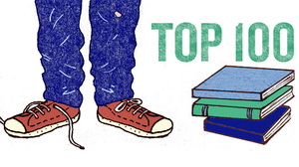
Harriet Russell
text size AAA
August 7, 2012
It's almost a cliche at this point to say that teen fiction isn't just for teens anymore. Just last year, the Association of American Publishers ranked Children's/Young Adult books as the single fastest-growing publishing category.
Which is why we were only a little surprised to see the tremendous response that came in for this summer's Best-Ever Teen Fiction poll. A whopping 75,220 of you voted for your favorite young adult novels, blasting past the total for last year's science fiction and fantasy poll at, dare we say it, warp speed.
And now, the final results are in. While it's no surprise to see Harry Potter and the Hunger Games trilogy on top, this year's list also highlights some writers we weren't as familiar with. For example, John Green, author of the 2012 hit The Fault in Our Stars, appears five times in the top 100.
Selecting a manageable voting roster from among the more than 1,200 nominations that came in from readers wasn't easy, and we were happy to be able to rely on such an experienced panel of judges. But deciding what does and doesn't count as a young-adult novel isn't an exact science. If you're surprised not to see some of your favorite books among the winners, you might want to look at this blog post, which describes the thinking behind the tough calls.
Summer, like youth, is fleeting. But the books we read when we're young can stay with us for a lifetime. Here's hoping that when the school bell rings in a few short weeks, it will find you engrossed in just such a memorable read, selected by the NPR audience. Enjoy. (For your convenience, here's a printable version of the top-100 list, and here's a list of the 235 finalists.)
1
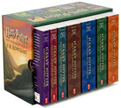
Harry Potter series
by J. K. Rowling
The adventures of Harry Potter, the Boy Who Lived, and his wand-wielding friends at the Hogwarts School of Witchcraft and Wizardry. Harry, Ron and Hermione must master their craft and battle the machinations of the evil wizard Voldemort and his Death Eaters.
2
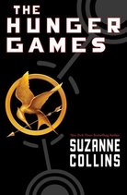
The Hunger Games series
by Suzanne Collins
In the ruins of a future North America, a young girl is picked to leave her impoverished district and travel to the decadent Capitol for a battle to the death in the savage Hunger Games. But for Katniss Everdeen, winning the Games only puts her deeper in danger as the strict social order of Panem begins to unravel.
3
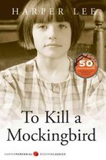
To Kill a Mockingbird
by Harper Lee
This Pulitzer Prize-winning novel from author Harper Lee explores racial tensions in the fictional "tired old town" of Maycomb, Ala., through the eyes of 6-year-old Scout Finch. As her lawyer father, Atticus, defends a black man accused of rape, Scout and her friends learn about the unjust treatment of African-Americans — and their mysterious neighbor, Boo Radley.
4
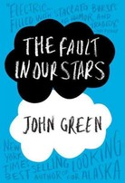
The Fault in Our Stars
by John Green
Despite the tumor-shrinking medical miracle that has bought her a few more years, Hazel has never been anything but terminal, her final chapter inscribed upon diagnosis. But when a gorgeous plot twist named Augustus Waters suddenly appears at the Cancer Kid Support Group, Hazel's story is about to be completely rewritten.
5
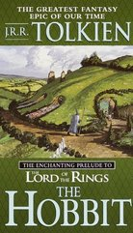
The Hobbit
by J.R.R. Tolkien
Bilbo Baggins, a respectable, well-to-do hobbit, lives comfortably in his hobbit hole until the day the wandering wizard Gandalf chooses him to take part in an adventure from which he may never return.
6
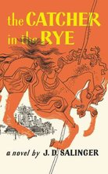
The Catcher in the Rye
by J.D. Salinger
With the author's death, the classic novel about young Holden Caulfield's disillusionment with the adult world and its "phoniness" will only rise in popularity — and controversy, since it is a favorite target of censors, who often cite profanity and sexual references in their efforts to ban the book.
7
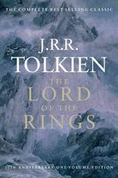
The Lord of the Rings
by J.R.R. Tolkien
Tolkien's seminal three-volume epic chronicles the War of the Ring, in which Frodo the hobbit and his companions set out to destroy the evil Ring of Power and restore peace to Middle-earth. The beloved trilogy still casts a long shadow, having established some of the most familiar and enduring tropes in fantasy literature.Literary Award Winner
8
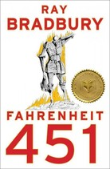
Fahrenheit 451
by Ray Bradbury
In a far future world, television dominates, and books are outlawed. The totalitarian regime has ordered all books to be burned by "firemen," whose job is to start the fires rather than stop them. But one fireman begins to see the value of the printed word.
9
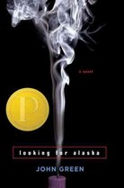
Looking for Alaska
by John Green
Sixteen-year-old Miles' first year at Culver Creek Preparatory School in Alabama includes good friends and great pranks, but is defined by the search for answers about life and death after a fatal car crash.
10
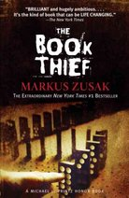
The Book Thief
by Markus Zusak
Trying to make sense of the horrors of World War II, Death relates the story of Liesel — a young German girl whose book-stealing and storytelling talents help sustain her family and the Jewish man they are hiding, as well as their neighbors.
11
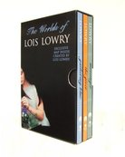
The Giver series
by Lois Lowry
In the future, society has eliminated discord, converting everyone to "Sameness." In three linked stories, Jonas, destined to hold memories of the time before Sameness; Kira, an orphan with a twisted leg; and healer Matty must discover the truth about their society and restore emotion, meaning and balance to their world.
12
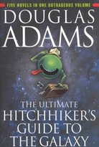
The Hitchhiker's Guide to the Galaxy series
by Douglas Adams
In this collection of novels, Arthur Dent is introduced to the galaxy at large when he is rescued by an alien friend seconds before Earth's destruction, and embarks on a series of amazing adventures, from the mattress swamps of Sqornshellous Zeta to the Restaurant at the End of the Universe.
13
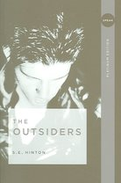
The Outsiders
by S.E. Hinton
S.E. Hinton was just 16 years old when she wrote this novel about kids getting caught up in class struggles. Ponyboy is a greaser, from the wrong side of the tracks; he runs afoul of the upper-class Socs, leading to an epic rumble between the two gangs.
14
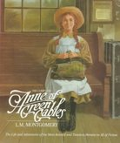
Anne of Green Gables series
by L.M. Montgomery
A collection of Lucy Maude Montgomery's eight novels starring the effervescent orphan Anne Shirley, beginning with her childhood on a farm on Canada's Prince Edward Island, and following her to marriage and motherhood.
15
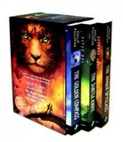
His Dark Materials series
by Philip Pullman
In this hit series, young Lyra Belacqua tries to prevent kidnapped children from becoming the subject of gruesome experiments; helps Will Parry — a boy from another world — search for his father; and finds that she and Will are caught in a battle between the angelic forces of the Authority and those gathered by her rebel uncle, Lord Asriel.
16
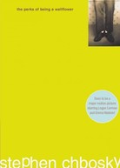
The Perks of Being a Wallflower
by Stephen Chbosky
In a thought-provoking coming-of-age novel, Charlie struggles to cope with the complex world of high school as he deals with the confusions of sex and love, the temptations of drugs, and the pain of losing a close friend and a favorite aunt.
17
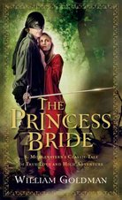
The Princess Bride
by William Goldman
This tale of a handsome farm boy who, aided by a drunken swordsman and a gentle giant, rescues a beautiful princess named Buttercup comes with a slyly humorous, metafictional edge: Goldman claims to have merely abridged an earlier text by one "S. Morgenstern" (actually a pseudonym) and peppers his text with clever commentary.
18
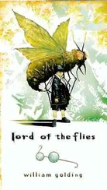
Lord of the Flies
by William Golding
The classic study of human nature depicts the degeneration of a group of schoolboys marooned on a desert island. Ralph, Piggy, Simon and their fellow castaways attempt to develop their own society — and fail disastrously.
19
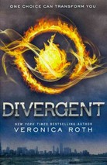
Divergent series
by Veronica Roth
In a future Chicago, 16-year-old Beatrice Prior must choose among five predetermined factions to define her identity for the rest of her life, a decision made more difficult when she discovers that she is an anomaly who does not fit into any one group, and that the society she lives in is not perfect after all.
20
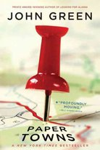
Paper Towns
by John Green
One month before graduating from his Central Florida high school, Quentin "Q" Jacobsen basks in the predictable boringness of his life, until the beautiful and exciting Margo Roth Spiegelman, Q's neighbor and classmate, takes him on a midnight adventure and then mysteriously disappears.
21
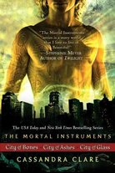
The Mortal Instruments series
by Cassandra Clare
Able to see demons and those who hunt them, Clary Fray is drawn into the world of the Shadowhunters when her mother slips into a coma and travels to the City of Glass, the capital of their secretive country, where she uncovers important truths about her family's past.
22
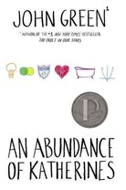
An Abundance of Katherines
by John Green
Always being dumped by girls named Katherine, Colin Singleton, a washed-up child prodigy with a Judge Judy-obsessed best friend, embarks on a quest to prove The Theorem of Underlying Katherine Predictability, which will affect all of his future relationships and change his life.
23
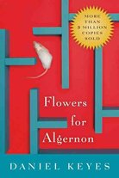
Flowers For Algernon
by Daniel Keyes
When brain surgery makes a mouse into a genius, dull-witted Charlie Gordon wonders if it might also work for him. It does ... but then the mouse begins to regress.
24
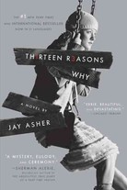
Thirteen Reasons Why
by Jay Asher
When high school student Clay Jenkins receives a box in the mail containing 13 cassette tapes recorded by his classmate Hannah, who committed suicide, he spends a bewildering and heartbreaking night crisscrossing their town, listening to Hannah's voice recount the events leading up to her death.
25
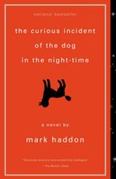
The Curious Incident of the Dog in the Night-Time
by Mark Haddon
Despite his overwhelming fear of interacting with people, Christopher, a mathematically gifted, autistic boy, decides to investigate the murder of a neighbor's dog and uncovers secrets about his mother.
26
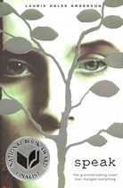
Speak
by Laurie Halse Anderson
After being raped at a party, teenage Melinda is unable to tell angry partygoers why she called the police — and eventually stops speaking all together. Speak follows Melinda as she overcomes her past, and finds her voice.
27
Twilight series
by Stephenie Meyer
When 17-year-old Bella Swan leaves Phoenix to live with her father in Forks, Wash., she meets Edward, an exquisitely handsome boy at school, for whom she feels an overwhelming attraction, and who she comes to realize is not wholly human. Bella must choose between vampire Edward and werewolf Jacob, while avoiding the attentions of less friendly vampires.
28
Uglies series
by Scott Westerfeld
Scott Westerfeld's four-part series follows teenage Tally as she uncovers the truth about her future world, where a mandatory operation at age 16 converts natural "Uglies" into conformist "Pretties."
29
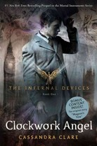
The Infernal Devices series
by Cassandra Clare
Tessa Gray's search for her missing brother leads her into Victorian London's supernatural underworld, where she must learn to trust the demon-killing Shadowhunters if she wants to learn to control her powers and find her brother.
30
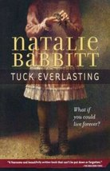
Tuck Everlasting
by Natalie Babbitt
The Tuck family is confronted with an agonizing situation when they discover that a 10-year-old girl and a malicious stranger now share their secret, about a spring of magical water that prevents the drinker from ever growing any older.
31
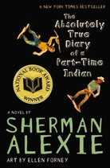
The Absolutely True Diary of a Part-Time Indian
by Sherman Alexie
Leaving the Spokane Indian Reservation to attend an all-white high school, Junior struggles to find his place in his new surroundings in order to escape his destiny back on the reservation. Literary Award Winner
32
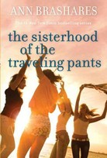
The Sisterhood of the Traveling Pants series
by Ann Brashares
During their first summer break spent apart, longtime friends Lena, Tibby, Carmen and Bridget each embark on adventures that they share with each other through a pair of jeans that they have decided will be worn by all, and so will absorb all of their stories.
33
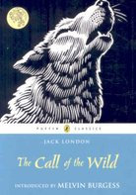
The Call of the Wild
by Jack London
Jack London's classic novel presents the adventures of an unusual dog, part Saint Bernard and part Scotch shepherd, forcibly taken to the Klondike gold fields, where he eventually becomes the leader of a wolf pack.
34
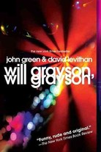
Will Grayson, Will Grayson
by John Green and David Levithan
When two teens, one gay and one straight, meet accidentally and discover that they share the same name, their lives become intertwined as one begins dating the other's best friend, who produces a play revealing his relationship with them both.
35
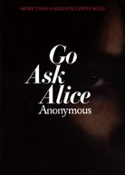
Go Ask Alice
by Anonymous
Originally sold as the real diary of an actual teenager, Go Ask Alice is the faux-memoir of a 15-year-old girl whose life is dominated by her drug problems, following her experiences from her indoctrination into the world of drugs to just before her death from an overdose.
36
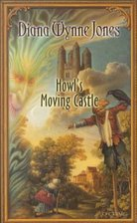
Howl's Moving Castle
by Diana Wynne Jones
The eldest of three sisters in a land where being the eldest is considered a misfortune, Sophie is resigned to her fate as a hat shop apprentice — until a witch turns her into an old woman, and she finds herself in the castle of the greatly feared wizard Howl.Literary Award Winner
37
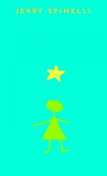
Stargirl
by Jerry Spinelli
Mica Area High School has never seen anything like Susan "Stargirl" Caraway, a classic Manic Pixie Dream Girl who wears Native American buckskins, plays the ukulele and cheers for both teams at sporting events. A story about the perils of popularity, the courage of nonconformity, and the thrill of first love.
38
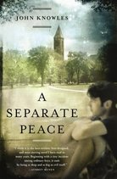
A Separate Peace
by John Knowles
Introverted, intellectual Gene and his daredevil best friend, Phineas, are roommates at a posh New England boarding school just before World War II, but a conflict of loyalties leads them to tragedy.
39
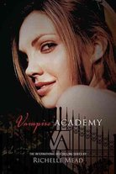
Vampire Academy series
by Richelle Mead
Two years after a horrible incident made them run away, vampire princess Lissa and her guardian-in-training Rose are found and returned to St. Vladimir's Academy, where one girl focuses on mastering magic, the other on physical training, while both try to avoid the perils of gossip, cliques, gruesome pranks and sinister plots.
40
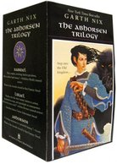
Abhorsen Trilogy
by Garth Nix
In the Old Kingdom, magic is real and the dead walk — and sometimes, they walk right across the magical Wall and into the New Kingdom. The series follows skilled necromancer Sabriel and her companions as they fight to send the dead back into the realm of Death.
41
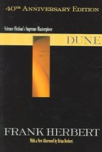
Dune
by Frank Herbert
Paul Atreides, the son of a betrayed duke, is given up for dead on a treacherous desert planet and adopted by its fierce, nomadic people, who help him unravel his most unexpected destiny.
42
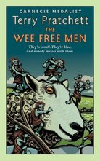
Discworld / Tiffany Aching series
by Terry Pratchett
In a remote corner of Terry Pratchett's Discworld, a young witch-to-be named Tiffany Aching teams up with the Wee Free Men, a clan of rowdy, 6-inch-high blue men, to rescue her baby brother and ward off a sinister invasion from Fairyland.
43
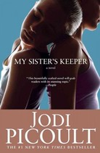
My Sister's Keeper
by Jodi Picoult
Conceived to provide a bone marrow match for her leukemia-stricken sister, teenage Anna begins to question her moral obligations in light of countless medical procedures, and decides to fight for the right to make decisions about her own body.
44
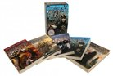
The Dark is Rising Sequence
by Susan Cooper
Five novels steeped in British and Welsh mythology follow the story of 11-year old Will Stanton, seventh son of a seventh son and last of the Old Ones, in his quest to vanquish the powers of the Dark.
45
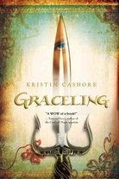
Graceling series
by Kristin Cashore
In the Graceling realms, rare people are Graced with a special skill — cooking, fighting, singing, building, lying — and all the Graced are marked with eyes of two different colors. Katsa, niece of the tyrannical king, is graced with fighting — or so she thinks.
46
Forever...
by Judy Blume
Katherine and Michael, along with various friends and acquaintances in suburban New Jersey, discover the possibilities and limitations of love and personal commitment — and some interesting names for body parts.
47
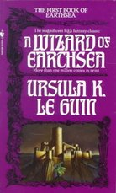
Earthsea series
by Ursula K. Le Guin
Yearning for knowledge and power, Sparrowhawk, a young student at the School for Wizards, becomes overanxious and tries his dangerous powers too soon, unleashing a terrible evil throughout the land, as he prepares for his destiny as the greatest sorcerer in the history of Earthsea.
48
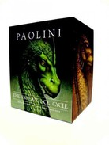
The Inheritance Cycle
by Christopher Paolini
The series that began with Eragon follows poor farm boy Eragon as he grows into a master swordsman who fights alongside his dragon, Saphira, to help save the Empire from evil and darkness.
49
The Princess Diaries series
by Meg Cabot
Fourteen-year-old Mia, who is trying to lead a normal life as a teenage girl in New York City, is shocked to learn that her father is the Prince of Genovia, a small European principality, and that she is a princess and the heir to the throne.
50
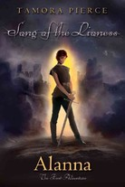
Song of the Lioness series
by Tamora Pierce
Eleven-year-old Alanna wants to be a knight. Her brother Thom wants to be a wizard. So she disguises herself as a boy and the two switch places, leading Alanna to a lifetime of adventure as the Kingdom of Tortall's first Lady Knight.
51
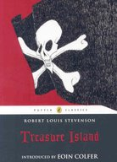
Treasure Island
by Robert Louis Stevenson
While going through the possessions of a deceased guest who owed them money, an innkeeper and her son find a treasure map that leads them across the Spanish Main to a notorious pirate's treasure. This classic novel introduced the world to the dreaded Long John Silver.
52
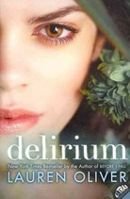
Delirium series
by Lauren Oliver
In a dystopian near future America, the government has classified love as a disease. All citizens, once they turn 18, receive a government operation to cure the unwanted emotion. Lena looks forward to her operation and a safe, predictable and happy life — until, just a few months before her 18th birthday, she meets the mysterious Alex and falls in love.
53
Anna and the French Kiss
by Stephanie Perkins
When Anna's romance-novelist father sends her to an elite American boarding school in Paris for her senior year of high school, she goes reluctantly — and meets the amazing Etienne St. Clair. Will their year of near-misses lead to love?
54
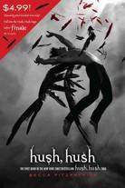
Hush, Hush Saga
by Becca Fitzpatrick
In the first volume of the "Hush, Hush" saga, high school sophomore Nora Grey must deal with her feelings for Patch, a classmate — and biology partner — who turns out to be a fallen angel.
55
13 Little Blue Envelopes
by Maureen Johnson
When 17-year-old Ginny receives a bequest — a packet of mysterious envelopes — from her favorite aunt Peg, she leaves New Jersey to crisscross Europe on a whirlwind tour and scavenger hunt that transforms her life.
56
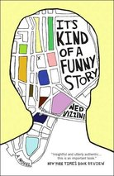
It's Kind of a Funny Story
by Ned Vizzini
An ambitious new student at Manhattan's prestigious Executive Pre-Professional High School, Craig Gilner suddenly discovers that he has become an average kid among a group of brilliant students, a discovery that leads to increasing anxiety and a battle with clinical depression, during which he encounters a motley crew of fellow patients battling their own problems.
57
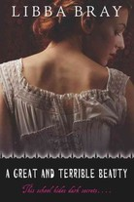
The Gemma Doyle Trilogy
by Libba Bray
After the suspicious death of her mother in 1895, 16-year-old Gemma returns to England, after many years in India, to attend a finishing school. There, she becomes aware of her magical powers and ability to see into the spirit world. But what will she find in that strange world?
58
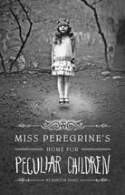
Miss Peregrine's Home for Peculiar Children
by Ransom Riggs
After a family tragedy, Jacob feels compelled to explore an abandoned orphanage on an island off the coast of Wales, discovering that the children once kept there — including his own grandfather — may have been dangerous, and may be still alive.
59
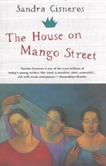
The House on Mango Street
by Sandra Cisneros
For Esperanza, a young girl growing up in the Hispanic quarter of Chicago, life is an endless landscape of concrete and run-down tenements. She tries to rise above the hopelessness, and come into her own power.
60
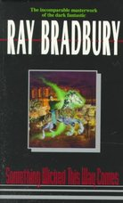
Something Wicked This Way Comes
by Ray Bradbury
When a sinister carnival comes to town just before Halloween, two boys unearth the terrifying and horrible secrets that lurk within Cooger & Dark's Pandemonium Shadow Show — and learn the consequences of wishes, as an evil force is at work in Green Town, Ill.
61
The Chocolate War
by Robert Cormier
The world of Trinity School is turned upside down when freshman Jerry Renault refuses to sell chocolates for the school's annual fundraiser. Jerry becomes a nonconformist hero for some — and a target of hatred for others.
62
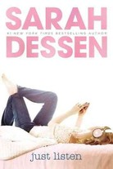
Just Listen
by Sarah Dessen
Suddenly unpopular 16-year-old Annabel finds an ally in classmate Owen, whose honesty and passion for music help her to face what really happened at the end-of-the-year party that changed her life.
63
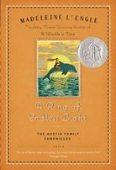
A Ring of Endless Light
by Madeleine L'Engle
Struggling to confront her grandfather's impending death, 16-year-old Vicky Austin finds herself the center of attention for three young men, one of whom is a dolphin researcher. When the inevitable crisis comes, she must rely on the love of others — both human and dolphin — to overcome her grief.
64
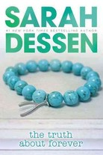
The Truth About Forever
by Sarah Dessen
The summer after her father's death, Macy plans to work at the library and wait for her brainy boyfriend to return from camp; instead, she goes to work at a catering business where she makes new friends and finally faces her grief.
65
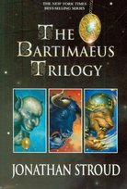
The Bartimaeus Trilogy
by Jonathan Stroud
In an alternate London, where magic is real and the Crystal Palace never burned down, magician's apprentice Nathaniel summons the 5,000-year-old djinni Bartimaeus — but summoning and controlling are two different things.
66
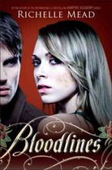
Bloodlines series
by Richelle Mead
When alchemist Sydney is ordered into hiding to protect the life of Moroi princess Jill Dragomir, the last place she expects to be sent is a human private school in Palm Springs, Calif. There, amid the wealthy students, Sydney and Jill must attempt to pass as normal.
67
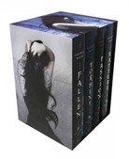
Fallen series
by Lauren Kate
Luce ends up at reform school after her boyfriend dies in a mysterious fire. While there, she finds herself drawn to Daniel — feeling almost as if she'd met him before. That feeling turns out to be true: Luce and the supernatural Daniel are doomed lovers, fated to lose each other in lifetime after lifetime.
68
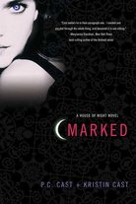
House of Night series
by P.C. Cast and Kristin Cast
Sixteen-year-old Zoey Redbird is Marked as a fledging vampyre and joins the House of Night school, where she will train to become an adult vampyre — if she makes it through the Change. And even for Changed vampyres, the House of Night can be a treacherous place.
69
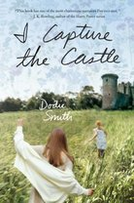
I Capture the Castle
by Dodie Smith
Seventeen-year-old Cassandra Mortmain lives with her older sister, blocked-writer father and bohemian stepmother in a crumbling English castle. Then, a well-to-do American family buys the castle, becoming the Mortmains' landlords. Cassandra uses a diary to record the tumultuous months that follow.
70
Nick & Norah's Infinite Playlist
by Rachel Cohn and David Levithan
High school student Nick O'Leary, member of a rock band, meets college-bound Norah Silverberg and asks her to be his girlfriend for five minutes in order to avoid his ex-sweetheart. That fateful five minutes leads to an all-night quest to find their favorite band's secret show.
71
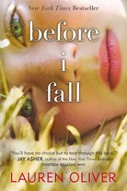
Before I Fall
by Lauren Oliver
Popular, thoughtless Samantha dies in a fiery car crash — but wakes up the next morning, and ends up living out her last day alive seven times in a row, until she finally unravels the mystery of her death.
72
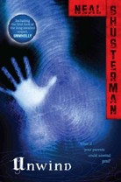
Unwind
by Neal Shusterman
In a future world where those between the ages of 13 and 18 can have their lives "unwound" and their body parts harvested for use by others, three teens go to extreme lengths to survive until they turn 18.
73
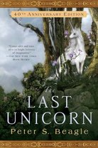
The Last Unicorn
by Peter S. Beagle
The last unicorn leaves the protection of her enchanted lavender forest to search for her own kind, with the assistance of Schmedrick, the only occasionally successful magician, and dreamer Molly Grue.
74
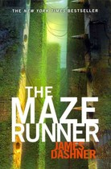
The Maze Runner series
by James Dashner
Sixteen-year-old Thomas wakes up in the middle of a maze, with no memory, and realizes he must work with the community in which he finds himself if he is to escape. But once he escapes, he discovers the outside world is a new and dangerous place.
75
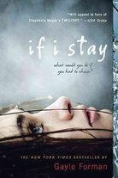
If I Stay
by Gayle Forman
Seventeen-year-old Mia is in a coma after a terrible car accident that killed her parents. Awakening, she has no memory of the accident, and must put her life back together piece by piece — and decide what to do with it.
76
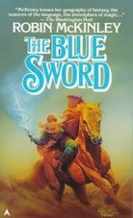
The Blue Sword
by Robin McKinley
Harry Crewe's boring life in the remote orange-growing province of Daria is disrupted when she's kidnapped by a native king. She discovers power within herself and becomes the heroic Harimad-sol, King's Rider and heir to a magical sword.
77
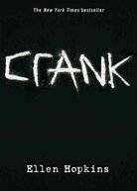
Crank series
by Ellen Hopkins
Kristina Snow is the perfect daughter, until she meets a boy who introduces her to drugs. She becomes a very different person, struggling to control her life and her mind, as she grows up and has children of her own.
78
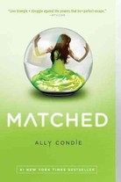
Matched series
by Ally Condie
Cassia has always trusted the Society to make the right choices for her, so when Xander appears on-screen at her Matching ceremony, Cassia knows he is her ideal mate — until Ky Markham's face appears for an instant before the screen fades to black.
79
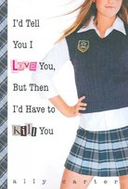
Gallagher Girls series
by Ally Carter
Cammie Morgan can speak 14 different languages, hack CIA computer codes and kill a man seven different ways. She and her friends are students at the elite Gallagher Academy for Exceptional Young Women, where martial arts and chemical warfare are on the curriculum, and the real mission is training spies.
80
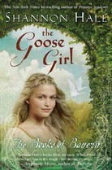
The Goose Girl
by Shannon Hale
On her way to marry a prince she's never met, Princess Anidori is betrayed by her guards and her lady-in-waiting, and must become a goose girl to survive until she can reveal her true identity and reclaim the crown that is rightfully hers.
81
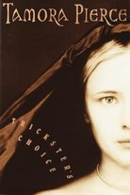
Daughter of the Lioness / Tricksters series
by Tamora Pierce
Alianne, the teenage daughter of Alanna, the first lady knight in Tortall, is kidnapped and sold into slavery, forced to serve an exiled royal family in the remote Copper Islands, where she is immersed in a world of murder, intrigue and warring gods.
82
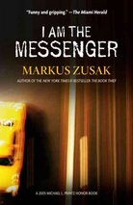
I Am the Messenger
by Markus Zusak
The dull and drab life of Ed, an underage cab driver with a coffee-addicted dog, takes an unexpected turn when he accidentally stops a bank robbery and finds himself being placed in charge of watching out for the entire town.
83
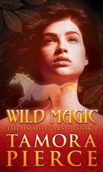
The Immortals series
by Tamora Pierce
Thirteen-year-old Daine's magic allows her to speak to animals, hear their thoughts, and shift into their forms. She uses her powers to help battle an invasion of terrible immortal creatures and prevent the overthrow of her king.
84
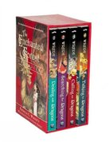
The Enchanted Forest Chronicles
by Patricia C. Wrede
Princess Cimorene of Lindenwall decides she's had enough of being a princess, and hires herself out to cook for the dragon Kazul. This boxed set follows her adventures, and those of her son Daystar.
85
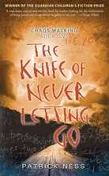
Chaos Walking series
by Patrick Ness
On a "New World" where all men can hear each other's thoughts — but women remain private — Todd and Viola are pursued by power-hungry Prentiss and mad minister Aaron as they search for answers about their colony's true past, and seek a way to warn a ship bringing settlers from the Old World.
86
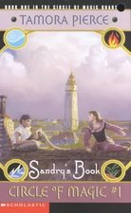
Circle of Magic series
by Tamora Pierce
Having been sent to Winding Circle Temple, Daja, Briar, Tris and Sandry begin to feel that they have finally found a place where their magical gifts are respected. As they learn and grow in their skills, they must face down everything from pirates to strange diseases.
87
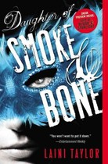
Daughter of Smoke & Bone
by Laini Taylor
Seventeen-year-old Karou, a lovely, enigmatic art student living in Prague, has a necklace of wish-granting beads and a sketchbook of hideous, frightening monsters — the chimaerae who form the only family she has ever known.
88
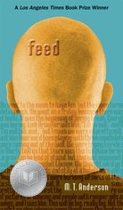
Feed
by M. T. Anderson
In the future, most people will have a Feed chip implanted in their heads that connects everyone to an evolved version of the Internet — at the cost of even basic privacy. During spring break on the moon, Titus and Violet meet and build a relationship when their Feeds are hacked.
89
Weetzie Bat series
by Francesca Lia Block
Five novels of life in a magical modern Los Angeles, where Weetzie Bat and her friends and family — Dirk, Duck, My Secret Agent Lover Man and baby Cherokee — interact with ghosts from their past and with each other as they search for love, connection and acceptance.
90
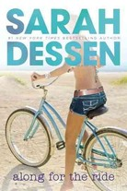
Along for the Ride
by Sarah Dessen
When Auden goes to stay with her father, stepmother and new baby sister the summer before she starts college, all the trauma of her parents' divorce is revived, even as she is making new friends and learning that there's more to life than schoolwork and perfectionism.
91
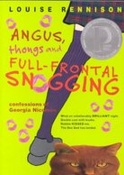
Confessions of Georgia Nicolson series
by Louise Rennison
The lives and loves of British teenager Georgia Nicolson and her friends in the "Ace Gang," and also Georgia's mad cat Angus. Can Georgia choose between hunky Robbie, Italian stallion Masimo and close friend Dave? And can she keep Angus out of trouble?
92
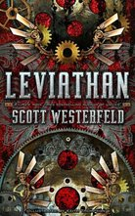
Leviathan series
by Scott Westerfeld
It's 1914 and Europe is on the precipice of war — the German Clankers and British Darwinists are armed with futuristic weaponry and biotechnology; in the midst of the chaos, Alek, a royal and potential threat to the throne, and Deryn, a common Darwinist, meet on the run and forge an uneasy alliance that will dramatically change the course of the Great War and their lives.
93
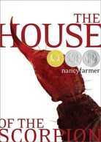
The House of the Scorpion
by Nancy Farmer
In a future where humans despise clones, Matt enjoys special status as the young clone of El Patron, the 142-year-old leader of a corrupt drug empire nestled between Mexico and the United States. Escape is his only chance to survive — but even that may not save him.
94
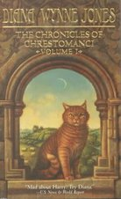
The Chronicles of Chrestomanci
by Diana Wynne Jones
Christopher Chant is a young boy who struggles with even the most basic spells — but when a wizard tests him, he discovers he's actually a powerful enchanter with nine lives, destined to become the next Chrestomanci, a government official in charge of supervising magic.
95
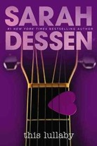
This Lullaby
by Sarah Dessen
Remy, a girl who always knows how to end a relationship before it becomes emotional, meets her match in Dexter, a musician who embodies everything that she despises and reminds her of the father who abandoned her. Remy finds herself unable to dump Dexter — and learns to follow her heart.
96
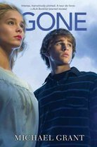
Gone series
by Michael Grant
When everyone over the age of 14 suddenly disappears from a California town, a battle erupts between the remaining residents and the students from a local school, as well as those who have "The Power" and those who do not.
97
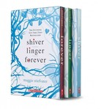
Shiver Trilogy
by Maggie Stiefvater
Grace has been visited each winter by a yellow-eyed wolf — a werewolf, it turns out, who becomes her boyfriend in his human form as Sam. Grace and Sam must fight to stay together, while fellow werewolf Cole wrestles with his attraction for rich girl Isabel.
98
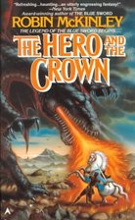
The Hero and the Crown
by Robin McKinley
Aerin, with the guidance of the wizard Luthe and the help of the blue sword Gonturan, wins the birthright due her as the daughter of the Damarian king and a witchwoman of the mysterious, demon-haunted North.
99
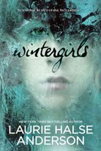
Wintergirls
by Laurie Halse Anderson
Estranged best friends Lia and Cassie both struggle with anorexia and bulimia. When Cassie dies, Lia must find a way to hold on to hope, and eventually to recover.
100
